

TASK
Exploratory Data Analysis on the US Arrests Dataset



Introduction
This dataset contains a comprehensive set of information, including a list of US states and their respective crime statistics for murder, assault and rape, as well as the population of each state.

DATA CLEANING
Data cleaning and preparation techniques were applied to ensure clarity, accuracy, and compatibility with the visualisation tools used. City names were set as the index to improve referencing and organisation of the dataset, which also enhanced axis readability and prevented label overlap during plotting. Indexing the cities additionally helped reduce the risk of duplicated identifiers.
The dataset was reshaped from wide format to long format using the melt() function. This process put the crime variables (Murder, Assault, and Rape) into a single column labelled Crime Type, producing tidy data suitable for grouped visualisations in Seaborn. This restructuring reduced repetition and improved interpretability.
Various visualisations were utilised to display and communicate patterns in the data. The Stacked and grouped bar charts showed arrest counts and examine the various crime types. A correlation heatmap assessed the relationships between murder, assault and rape statistics, given its display of colour and correlation values. Finally, a combined bar and line chart compared crime statistics alongside the urban population size, by this it gave additional context while being descriptive.

MISSING DATA

This dataset did not contain any missing data. All necessary variables were clearly identifiable under the columns Murder, Assault, Rape, and Urban Population size and were ready for analysis. As a result, no row removal or cell alterations were required.

This preserved the integrity of the original data and ensured that the visualisations accurately represented the reported crime statistics and urban population figures.

DATA STORIES AND VISUALISATIONS

# Data story 1

The heatmap visualisation in Figure 1 below illustrates the strength of the relationships between murder, assault, and rape statistics through correlation values. This type of visualisation was chosen because it provides a clear way to compare how closely related different crime types are, using both colour intensity and numerical coefficients to highlight patterns.

The strongest relationship is observed between assault and murder, with a correlation value of 0.80, indicating a strong positive relationship. This suggests that increases in assault figures tend to occur alongside increases in murder figures. While this does not imply causation, it points to the possibility that these crimes may share similar underlying conditions or broader contributing factors.

A moderate positive relationship exists between assault and rape, with a correlation of 0.67. This depicts that although these two crime types are related, the relationship is weaker than that observed between assault and murder. This indicates that changes in assault levels are not as closely mirrored by changes in rape statistics.

The weakest relationship is observed between murder and rape, with a correlation value of 0.56. Although still positive, this lower correlation indicates that these two crime types are less closely related compared to the other pairings.

Overall, the visualisation highlights that all three crime types are positively related, but to varying degrees. Assault appears to be more strongly associated with the other crime types, suggesting it may play a central role in overall violent crime patterns. However, the correlations shown do not indicate direct succession of events.

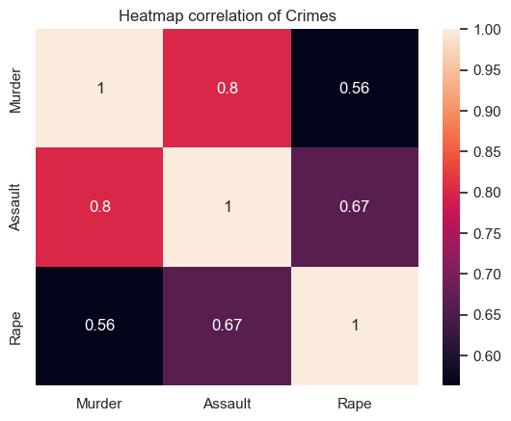
Figure 1: Heatmap correlation of Crimes

# Data story 2

Figure 2’s stacked horizontal bar chart visualises the distribution of arrest counts for murder, assault, and rape across observations indexed along the y-axis. This visualisation was selected because it allows both comparison of total arrest volumes and examination of how each crime type contributes to the overall total within each observation.

Across the chart, assault consistently forms the largest portion of the stacked bars, indicating that it accounts for the majority of arrests when compared to murder and rape. Variations in total arrest counts across the observations are therefore primarily driven by differences in assault levels rather than murder or rape.

Murder contributes the smallest portion to the total arrest figures throughout the chart. Its relatively low and stable values suggest that changes in total arrests are less influenced by fluctuations in murder counts.
Rape contributes a moderate share to the overall totals. While generally smaller than assault, its contribution varies more noticeably than murder across observations, indicating that it plays a secondary but non-negligible role in shaping total arrest volumes.

Overall, the visualisation shows that differences in total arrest figures are largely explained by variations in assault, with rape providing additional variations and murder contributing minimally in comparison. The chart supports comparative analysis of crime composition but does not provide information on causality, temporal order, or individual behaviour. Conclusions drawn are therefore limited to differences in magnitude and composition as presented in the data.

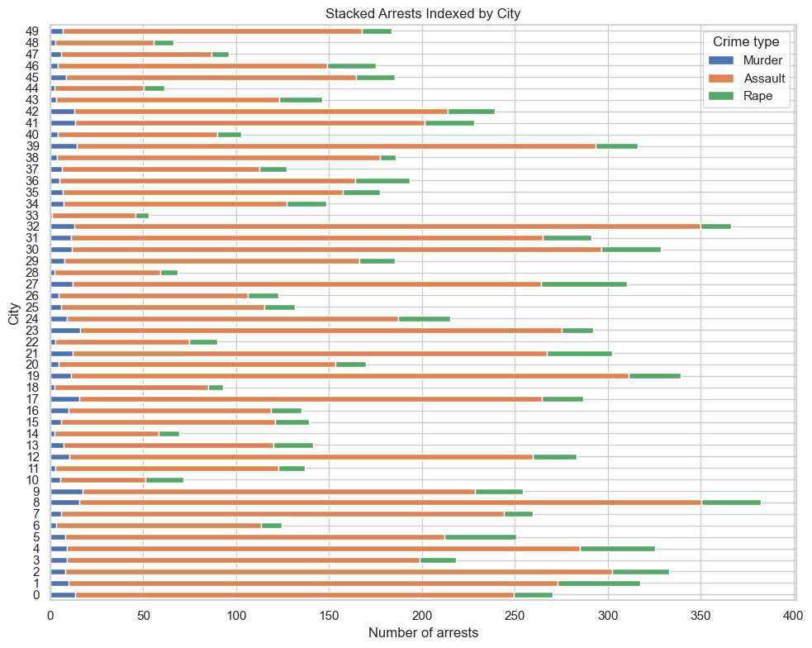
Figure 2: Stacked Arrests Indexed by City

# Data story 3

This visualisation combines a grouped bar chart and a line chart to present arrest statistics for murder, assault, and rape, alongside urban population percentages, indexed by city. City indices are used on the x-axis to improve readability and avoid overlapping caused by long city labels.

The bar chart highlights that assault consistently records the highest number of arrests across most indexed cities, while murder remains comparatively low and stable. Rape shows moderate variation and contributes less to the total arrest count than assault but more than murder. This composition indicates that differences in overall arrest figures are largely driven by changes in assault levels.

The overlaid line graph represents Population, allowing visual comparison between arrest counts and urban population percentages across the same index. The placement over some city indexes having their Assault arrests surpass their Population sizes brings the assumption that some arrests could be from individuals who are multiple time offenders in some cities or some who are arrested might be from a different city. Another assumption from the data is that cities with larger populations tend to peak onto greater Assault arrests, while Rape remains moderately constant regardless of population size, however, this pattern is not consistent across all observations. As a result, the visual suggests variability rather than a uniform relationship between crime arrest levels and urban population percentages.

The use of a combined bar and line chart enables simultaneous comparison of crime composition and population context without implying causality. The visual supports exploratory analysis by revealing where arrest levels and urban population percentages appear to align or diverge, while remaining limited to descriptive insights based on observed patterns.

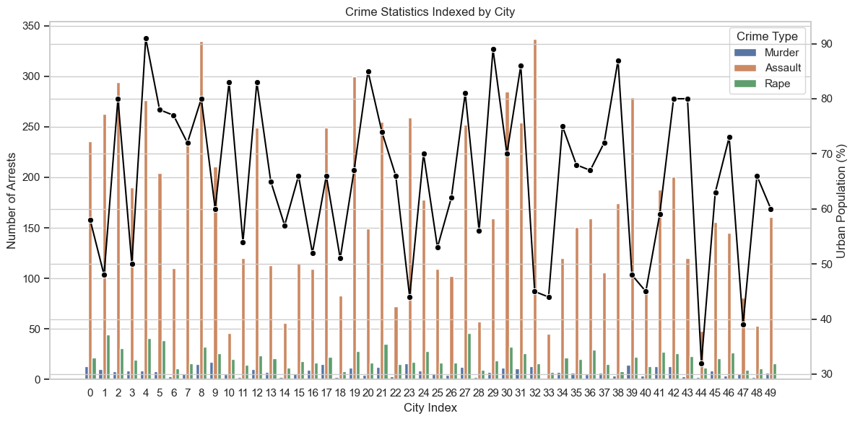
Figure 3: Crime Statistics Indexed by City

THIS REPORT WAS WRITTEN BY : Nokukhanya Sika

